30 | 20 | 50 | 100 | Grade
Class:9 SMAART

Name SUMMATIVE ASSESMENT-1
Roll No: Total marks:20
______________________________________________________________________________________________
1.Fill in the blanks (1M*5=5M) 1x5=5M
1.HTML stands for _____________________________Markup Language.
2.The ___________ tag is used for images in html.
3.CSS stands for _____________________ style sheets.
4.____________css is written inside <style> tag.
5.The outer space of an element is called ________________.
2. Identify the component and describe the functionality. 1x5=5M
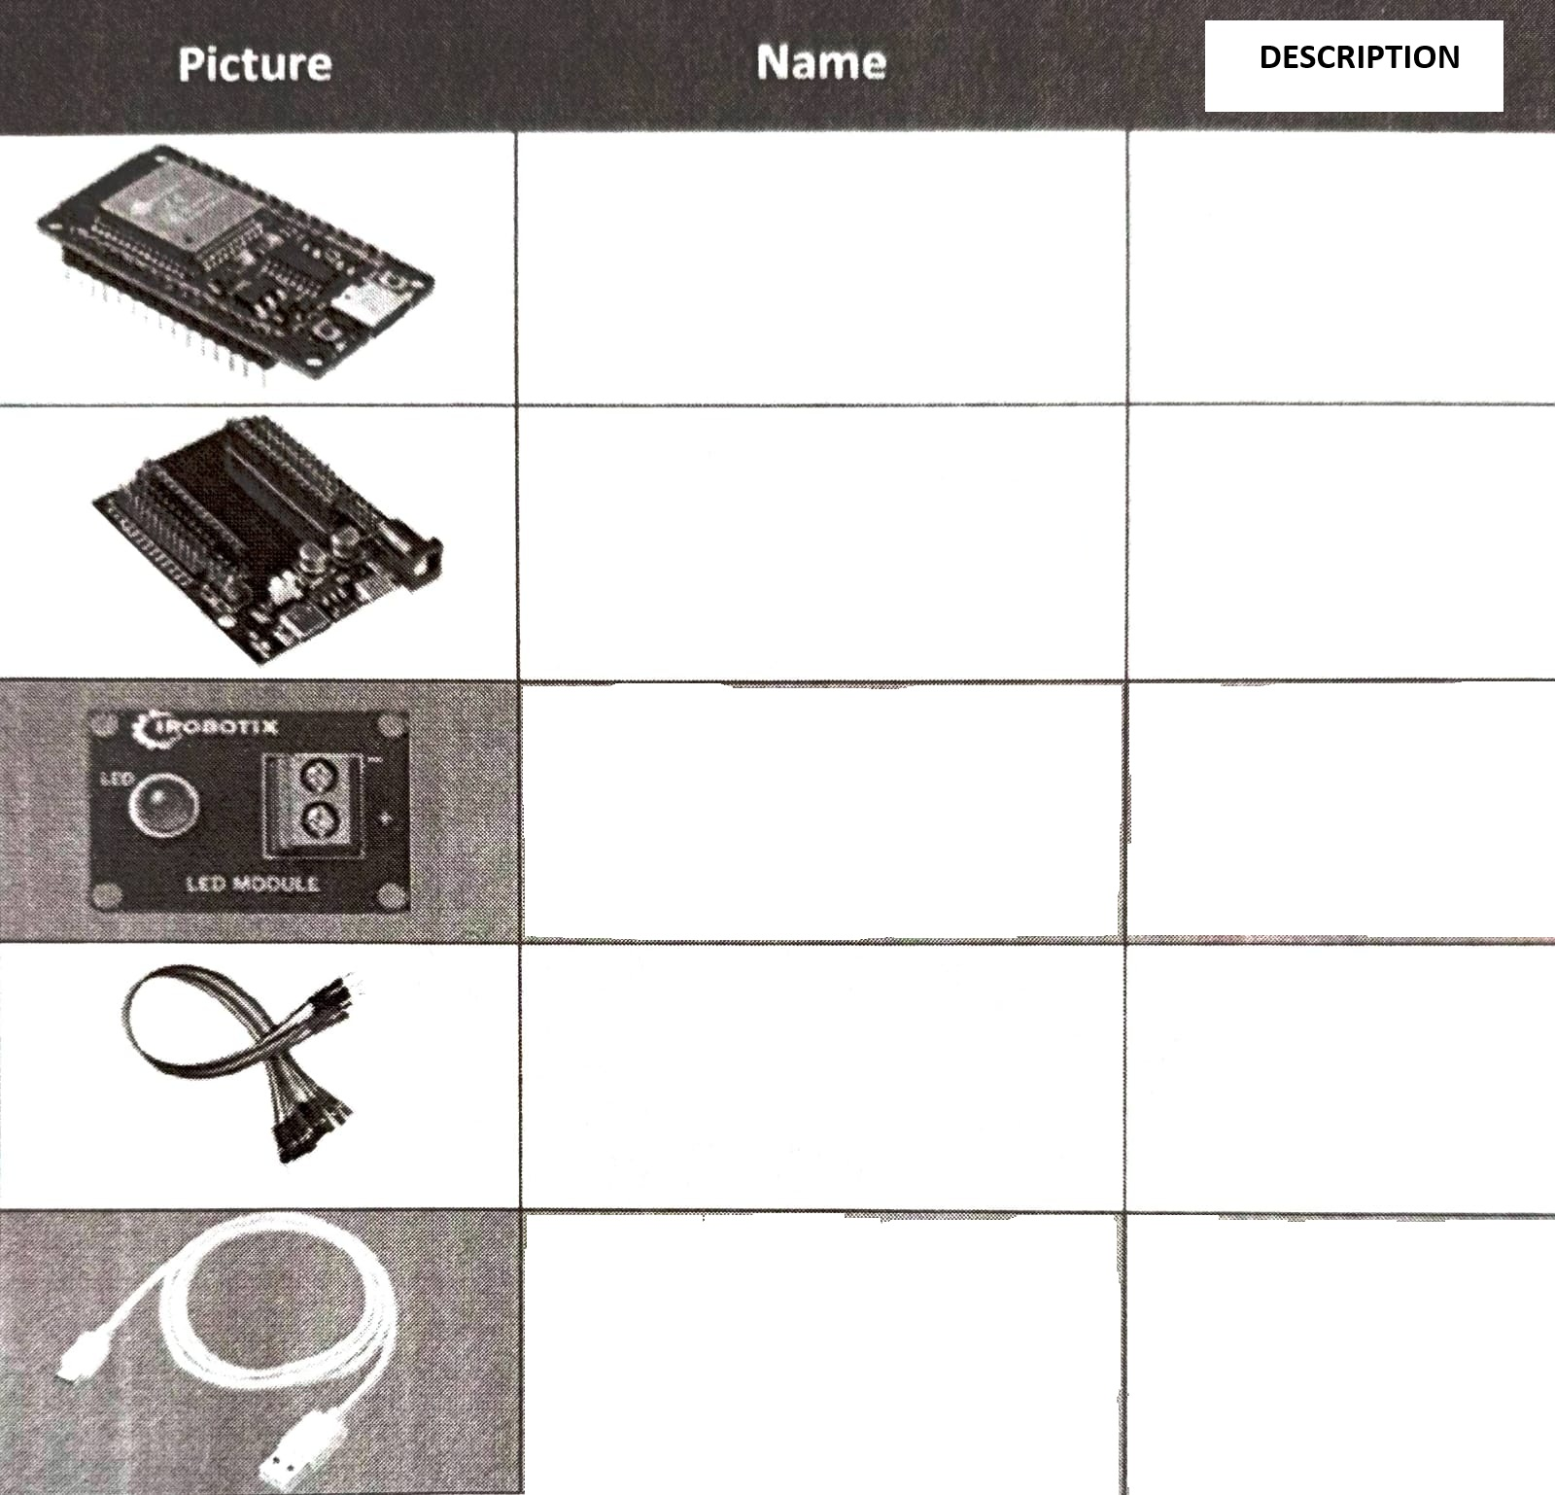

3. state whether the following statements are true or false. 1x5=5M
1.HTML is used to design the structure of the web pages ( ).
2. <img> tag requires a closing tag ( ).
3. Internet and WWW are the same ( )
4. web applications are interactive ( ).
5. links are created using <a> tag ( ).
4. select the correct option. 1x3=3M
1.Which tag is used to create paragraph?
a. <h1> b. <p> c. <br> d. <li>
2.In client-server model, who sends request?
a. Server b. Client
c. Browser d. Database
3.which display type takes full width?
a. Inline b. Inline-block c. Block d. Flex
5.Answer any 1 question of the following. 1x2=2M
1. Ramu wants to change the colour of the text, which CSS property would you use?
2. What is the difference between website and web application?

